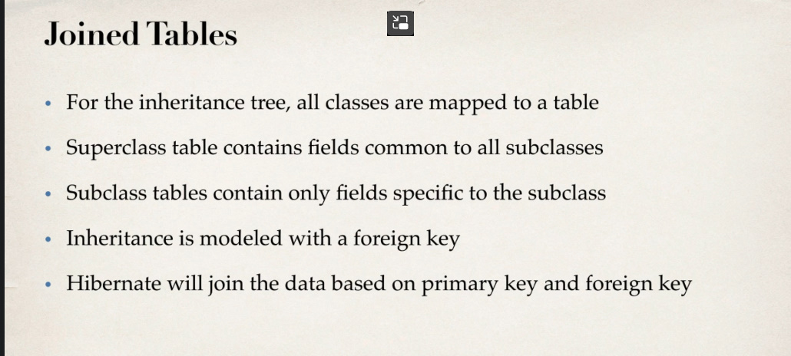

Strategia data se bazeaza ca avem un tabel pentru superclasa si tabele pentru subclase

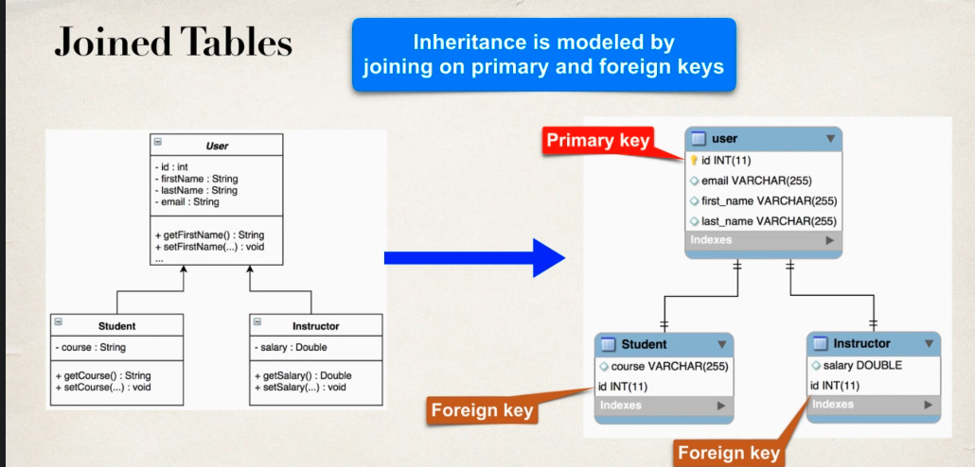

Primary Key din superclasa, adica user, este foreign key din subclase, adica din Student si Instructor(id)

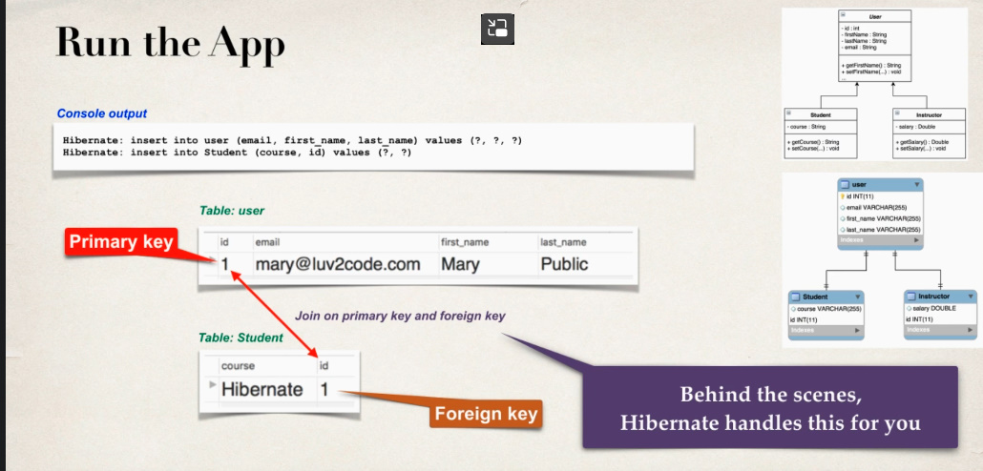

Hibernate singur va avea grija sa adauge valoarea in foreign key a id la student

SEQUENCE_TABLE nu mai e necesar

@Entity  
@Table(name = "user")  
@Inheritance(strategy = InheritanceType.*JOINED*)  
  
@Getter  
@Setter  
@NoArgsConstructor  
@AllArgsConstructor  
@ToString  
public class User {  
 @Id  
 @GeneratedValue(strategy = GenerationType.*IDENTITY*)  
 @Column(name = "id")  
 private int id;  
 @Column(name = "first_name")  
 private String firstName;  
 @Column(name = "last_name")  
 private String lastName;  
 @Column(name = "email")  
 private String email;  
}

@Entity  
@Table(name = "student")  
  
@Getter  
@Setter  
@NoArgsConstructor  
@AllArgsConstructor  
@ToString  
public class Student extends User{  
 @Column(name = "course")  
 private String course;  
}

@Getter  
@Setter  
@NoArgsConstructor  
@AllArgsConstructor  
@ToString  
public class Employee extends User {  
 @Column(name = "salary")  
 private double salary;  
}

Vedem ca la Student nu am pus nicaieri ceva legat de foriegn key, si nici nu trebuie. Hibernate singur va insera foreign key

{

    "firstName" : "Eduard",

    "lastName" : "Mititiuc",

    "email" : "test123",

    "course" : "Spring"

}

